CEN Workshop Agreement

Recommendations for making Climate Adaptation Plans for marine capture fisheries, marine aquaculture and freshwater lake and pond production
Contents
1. Foreword 3
2. Introduction 3
3. Scope 3
4. Normative references 4
5. Concepts, terms and definitions 4
6. Outline of the CAP Development Process 6
7. Limitations of the approach 6
8. Starting the CAP Development Process 7
8.1. Initiator of the CAP development process 7
8.2. Stakeholder identification 7
8.3. CAP kick-off meeting to determine stakeholder roles and involvement 8
8.4. CAP Agreement meeting 9
9. Making CAPs: Detailed description of key tasks for CAP development 10
9.1 Task One: Assessment of risks and opportunities 10
Task One: Step 1 – Breakdown production system into characteristics 10
Task One: Step 2 – Evaluate current status of characteristics in the face of climate change 11
Task One: Step 3 – Biological forecast 12
Task One: Step 4 –Scoring risks and opportunities by the stakeholders- the first stakeholder meeting 12
Task One: Step 5 – Scoring risks and opportunities by the scientists 13
9.2 Task Two: Identification of Adaptation measures 14
Task Two: Step 1 - Prioritizing the system’s characteristics 14
Task Two: Step 2 - Vulnerability assessment 15
Task Two: Step 3 - Identification of adaptation needs 18
Task Two: Step 4 - Setting indicators and outcome targets 19
Task Two: Step 5 - Setting adaptation measures- the second stakeholder meeting 20
9.3 Task Three: Procedure Plans 23
Task Three: Step 1 – AM task description 24
Task Three: Step 2 – Procedure allocations 24
Task Three: Step 3 – Resources 25
Task Three: Step 4 – Cost estimation 25
Task Three: Step 5 – Time Frame 25
10. Bibliography 27
11. Annex 28

Foreword
This document was prepared by participants in the research project “Co-creating a Decision Support Framework to Ensure Sustainable Fish Production in Europe under Climate Change” (or ClimeFish for short), a project funded by the European Commission within the Horizon 2020 Programme, grant agreement No 677039.

Introduction
Climate change has been observed to have a significant impact on the biology and ecology of several fish stocks and aquaculture species and is likely to further affect the productivity within seafood supply chains in the coming years, as climate scientists predict future warming for decades to come. To maximise the potential of European fish products under future climate change scenarios and minimize undesirable shocks and negative effects due to climate change, efficient and precautionary management, along with forward-minded decision-making on all levels, is crucial. By creating adaptive strategies to cope with future climate change, tailor-made not only for each specific sector, but for each component of a production system (specific industry or farm), managers, operators and other stakeholders can strategically reduce negative effects of climate change on their future production, while at the same time, find effective ways to utilize all potential opportunities that may arise.

Scope
What is the purpose of document?
The aim of this document is to offer an accessible and practical framework to create an effective Climate Adaptation Plan (CAP) within the fishing and aquaculture industry. This document contains guidelines for the development of Climate Adaptation Plans (CAPs) for three different seafood producing sectors: marine wild capture fisheries, marine aquaculture, and lake and pond production.
What are the outcomes of the CAP process?
The CAP development process results in identification of realistic and efficient adaptation measures for the seafood production system in question, with the aim to fulfil its adaptation needs, which are also identified during the process. The CAPs identify adaptation measures and suggest industry adaptation, policy recommendations and knowledge building.
Who is it for?
These guidelines are applicable for authorities and operators within all three sectors in question. The guidelines will be applicable to most fisheries, aquaculture and freshwater production systems in Europe that wish to prepare their business for future climate related changes, by effectively identifying key risks and opportunities, main vulnerabilities and subsequently, evaluate their ability to adapt to changes in their production system.
These sector specific CAPs and the subsequent guidelines and supporting documents will be of high relevance and interest to a wide range of users, from national and regional administrations (e.g. ministries and directorates in charge of aquaculture and fisheries), to the industry itself (e.g. producers’ organisations, fishing companies and fish farmers), and scientists/academia from the social and natural sciences.
How to make a CAP?
The guidelines presented in this document are in line with existing literature and adaptation tools on creating adaptation strategies (e.g. Barange, Bahri, Beveridge, Cochrane, Funge-Smith & Poulain, 2018. ; Brugére & De Young, 2015; Shelton, 2014; Glick, Stein & Edelson, 2011; Grafton, 2010; FAO, 2010; FAO, 2003; ) and describe a total of three distinct task, which include five steps each, to form a CAP for the production system in question in co-creation with key stakeholders; based on an ecosystem-based approach. These steps include a detailed analysis of each of the production system’s characteristics, risk assessment and prioritisation of the production system’s characteristics, a vulnerability assessment and identification of key adaptation needs and subsequent adaptation measures. Finally, each identified adaptation measure gets a procedure plan, outlining its subsequent implementation. All steps are designed and set up in order to enable the user to develop an applicable and effective CAP, tailored for the production system in question.
Requirements and limitations
The CAP development process requires a dedicated group of relevant active participants from both the industry and administrative/policy side, as well as social and natural scientists. It further requires extensive involvement of local experts and other relevant stakeholders throughout the process, which will promote more robust strategies with increased likelihood of being translated into actual management actions. By developing and implementing CAPs, users within all three sectors should be able to reduce the production system’s vulnerabilities towards climate change in the long-run. CAPs can further serve as a valuable source of information, addition to, or basis for a National Adaptation Plan (NAP), whether that is an existing NAP ready for revision or at an early development phase.
The CAP development process should only be pursued if a climate biological forecast for the target/farmed species in question, and a climate risk/opportunity assessment for the production system, have either been completed prior to entering the CAP process or can be conducted alongside the CAP process. These guidelines exclude details on the biological forecasting exercise and the risk/opportunity assessment.

Normative references
The following documents, in whole or in part, are normatively referenced in CAP guideline and are indispensable for its application. For dated references, only the edition cited applies. For undated references, the latest edition of the referenced document (including any amendments) applies.
- The most comprehensive assessment of climate change undertaken by the Intergovernmental Panel on Climate Change (IPCC), particularly the synthetic report of Climate Change (2014): Impacts, Adaptation, and Vulnerability. (IPCC, 2014)
- The work done by FAO- Fisheries and Aquaculture Technical Paper No. 597 on assessing climate change vulnerability in fisheries and aquaculture. Available methodologies and their relevance for the sector (Brugère, C., & De Young, C. 2015).
Sustainability and sustainable development framework introduced by Circular Ecology (http://www.circularecology.com/).

Concepts, terms and definitions
For the purposes of this document, the following terms and definitions apply.
Adaptive action: Once an adaptation need has been identified, an adaptive action is required to fill the adaptation need, in the form of one or more adaptation measures.
Adaptive capacity: The ability of production systems, institutions, humans and other organisms to adjust to potential damage, to take advantage of opportunities, or to respond to consequences.
Adaptation measures: Strategies and/or measures available and appropriate to address adaptation needs. Example: Increase use of fouling resilient materials and upgrade of infrastructures to reduce negative effects of biofouling.
Adaptation needs: The gap between what might happen as the climate changes and what we would desire to happen. This gap can be in the form of requirements for information, resources and actions, to ensure survival of key species, continued or increased seafood production and security of infrastructures in response to climate change. The desired state is termed “broad future objective”, which can refer to its health, size, growth rates, income, etc., all depending on the nature of the characteristic in question. Setting the broad future objective for a characteristic is a necessary step for identifying the adaptation needs, and is defined by posing the question: “What would the perfect scenario for this characteristic be in the future?”
CAP (Climate Adaptation Plan): A long-term adaptation strategy developed for a fishery, fish farm or national aquaculture industry under the ClimeFish CAP development process. It contains a set of strategically selected adaptation measures, presented in the form of industry level adaptation measures, policy recommendation and/or research needs, that together aim to fill the long-term adaptation needs identified within the industry in question, to the extent possible.
CAP Consortium: The group of active stakeholders who have signed a particular formal CAP agreement.
CAP Agreement: A formal CAP agreement includes information on the following elements of the CAP: List of active participants (name, organisation); Scope of the CAP and main outcomes; Timeline of the CAP development process; Cost estimation (including work allocation and funding of each participant, in line with the project plan); Project plan (accompanying document); Main challenges foreseen and how they will be addressed; List of signatures of CAP consortium.
CAP initiator: takes responsibility and leads the CAP development process and procedure.
Indicator: The unit or reference scale for which we aim to use to measure whether or not an outcome target (OT) has been reached. A “benchmark”, is a specific value of an indicator, providing a number that measurement results can be judged from and given significance. This provides comparisons between companies, sectors or production systems i.e. gives ranges for what to aim for and what can be considered “best practice”. Example: CO₂-emissions, oxygen saturation or salinity.
Likelihood: Likelihood is expressed as the probability of a climate event happening. The scale contains three levels – unlikely, possible and likely.
Opportunity: The possibility to obtain positive outcomes (consequences) from the occurrence of a climate-driven likely event. Example: Increase of biomass and production capacity.
Outcome target: Specific and measurable performance goals which we define for the adaptation measure within the fishery or aquaculture in question, based on the broad future objective. OTs are expressed as threshold values of the respective indicators. Example: Reduce the economic costs associated with biofouling effects and control (<5% of production cost).
Production System: All aspects of a fishery or a fish farm that relate to the production of the fish/shellfish seafood products, including biological, environmental, production, governmental and socio-economic aspects.
Reference group member: Relevant stakeholders need to be identified, either as members of the CAP consortium or the reference group. A reference group member is asked for specific inputs and given the opportunity to represent their interests within the process during stakeholder meetings.
Risk: The probability of and potential impacts from the occurrence of an event. Risk is understood as a combination of the likelihood of occurrence of an event and the magnitude of the impacts if this event occurs. Example: Shift in thermal window suitable for growth.
Stakeholders: All interested parties and potential participants in the CAP development process.
[System’s] Characteristics: A feature or quality of a production system (a specific fishery, fish farm or national aquaculture industry) that is important for the functioning and operation of the production system. A single production system can range from having anywhere between ten and 100 characteristics, which can be of biological, environmental, production, governmental and socio-economic nature.
Vulnerability: Vulnerability describes to what extent a production system or concerned parties, e.g. species, industries, communities, are susceptible to, or unable to cope with impacts of climate change, and depend on exposure, sensitivity and adaptive capacity.
Vulnerability assessment: A vulnerability assessment is constructed on a variety of biophysical and socioeconomic indicators and their vulnerability is analysed. The goal is to answer the question of “who or what is vulnerable to what?”. That can be done by asking “who is the vulnerable party/parties and how can their vulnerability be reduced, which are the vulnerable characteristics, where will the economic and social consequences be felt the most, how can plans be made to minimize them, where will climate change create opportunities and bring benefits, for whom?” The indicators’ vulnerability depends on their degree of exposure, sensitivity and capacity to cope with or adapt to a threat or utilize it to create opportunities. Examples of a VAs purposes are improving adaptation planning such as designing policies and interventions, raising awareness of risks and opportunities and promoting scientific research.

Outline of the CAP Development Process
In order to make CAPs, a series of assessments, considerations, task, and steps should be followed. The CAP development process (including stakeholder meetings) can be outlined as follows, in chronological order:
First, the CAP initiator takes responsibility and initiates the CAP development process and procedure. Then, all relevant stakeholders need to be identified, which can either become members of the CAP consortium or join the reference group. The roles of the stakeholders are decided during the CAP kick-off meeting. This is followed by the CAP agreement meeting, during which the key aspects of the CAP development process are discusses and formalized in the CAP agreement. After the CAP agreement has been agreed upon and signed by all CAP consortium members, the CAP development formally starts. The CAP consortium needs to follow three step-wise tasks to develop the CAP.
All these steps are described in detail below, within the respective sections under “General Guidelines for creating CAPs”, following the same chronological order.

Limitations of the approach
Due to potential adaptation constraints and limits, not all climate related high-risk impacts may be met with an adaptation measure. In other words, not all adaptation needs identified in the CAP process can always be met with an effective adaptive action. Furthermore, in some cases, not all adaptation measures that are identified in the CAP process will be possible to implement, e.g. due to insufficient or lack of resources, capacities or existing legislations. Lastly, some of the identified adaptation measures may not be able to meet the full adaptation needs, leaving a gap between the actual adaption need and the effectiveness of the adaptation measure. All of these potential limitations are a reality in adaptive planning to climate change (IPCC 2014), and this CAP development process is no exception.

Starting the CAP Development Process

Initiator of the CAP development process
The CAP initiator takes responsibility and leads the CAP development process and procedure. The CAP initiator can be any interested party with the objective to develop climate adaptation plans within marine fisheries or aquaculture, or within freshwater seafood sectors.

Stakeholder identification
The CAP initiator should identify and map the relevant stakeholders of the CAP development process.
Several techniques can be used for stakeholder identification. One easy way to identify stakeholders is to apply a stakeholder typology (based on Newton & Elliott, 2016), where stakeholders can be distinguished as follows:
- Extractors: Those using space or taking resources from the marine or freshwater production system.
- Inputters: Those discharging materials or placing materials or infrastructure into the marine or freshwater production system.
- Beneficiaries: Those benefitting from the ecosystem services and goods created by the production system and delivered by the extractors.
- Affected: Those affected by the extractors and inputters, affected by the policy decisions or impacted by the decisions.
- Regulators: Those giving permission to occupy space or to extract/input materials, those with a controlling rule in the production system, ‘hard’ and ‘soft’ regulators.
- Influencers: Those influencing policy and extraction/input.
In addition to applying a stakeholder typology, relevant social identities can be identified and cross mapped with the stakeholder types named above, to provide a more realistic and comprehensive approach to stakeholder identification (based on Crane & Ruebottom, 2011). Social identities could include: age-based groups (e.g. children, seniors), racial, national or ethnic-based groups, gender or sexuality-based groups, ability-based groups (e.g. blind, death, mental health), political or issue-based groups, location-based groups, role-based groups (e.g. parents, grandparents, students), and other social groups.
Examples of stakeholders could include:
- Sectoral authorities - Representatives from the sector’s key policy making bodies: the ministry in charge of the production system in question, directorates and directly related agencies.
- Main primary operators - Representatives of the operators who provide the raw material for processing: fishers, fishing companies, fishers and/or boat owners associations, fish farmers, aquaculture companies, farmers associations.
- Main secondary operators – Representatives of those who receive the raw material (where these are not the primary operators): Processing companies and others who sell and/or market the products, builders of infrastructure.
- Related agencies – Representatives of all main managers of resources/infrastructures that either affect or are affected by the production system in question, e.g. water managing authorities, environmental agencies, tourism, transport, and marine spatial planning, etc.
- Scientists/expert groups – Individual scientists and/or representatives from the scientific institution/company that has a special focus or interest in the production system should be included for expert knowledge on the expected impacts of climate change and input on the potential impacts of any adaptation actions identified in the CAP.
- NGOs, lobby groups, educators – individuals or representatives from groups that can influence and lobby for policy, resource use, infrastructure, etc.

CAP kick-off meeting to determine stakeholder roles and involvement
The purpose of the CAP kick-off meeting is to determine stakeholder roles and involvement. All identified stakeholders are invited to the CAP kick-off meeting, which can be a physical or electronic meeting. The meeting should additionally be announced on relevant online platforms or media, to reach additional potential stakeholders and to demonstrate openness and transparency.
During the CAP kick-off meeting, the CAP initiator outlines their sectors needs and the reasons and ambitions for starting a CAP development process to the stakeholders. At this meeting, all stakeholders can decide on their role and level of involvement during the CAP development process, depending on their interests, availability and capacity (in terms of resources). Stakeholders can be involved in the following roles, with the following work requirements:
CAP consortium member:
- Allocate effort within key steps of the CAP development process, depending on their expertise (as specified in the project plan);
- Assist with funding of the CAP development process in line with expected effort, either through own funding or external funding, in which they help collect (as specified in the cost estimate);
- Should preferably be included in the development of key documents prior to the CAP development process initiation, i.e. CAP project plan and cost estimation. Their validation and signature on these documents are required, as well as on the subsequent formal CAP agreement.
Reference group member:
- Will be informed throughout the process and consulted at relevant stages during the CAP development
- Invited to participate in (at least) two reference group meetings during the duration of the CAP development process, at their own expense.
- Asked for specific inputs and given the opportunity to represent their interests within the process during stakeholder meetings.
To conclude the kick-off meeting, the interested parties form the CAP Consortium and the reference group, and all the names and contact details of all consortium and reference group members are recorded.
After the kick-off meeting, the CAP initiator prepares a draft CAP development project plan, which should include the following items:
- Background: Information on the CAP development process, who is leading the process and its scope and objectives
- CAP development process participants: Information and contact details on all participants and their role as members of the CAP consortium or the reference group.
- CAP development work plan: Specific tasks within the CAP development process, the task leaders and their timescale for delivery.
- Resource requirements: with reference to the cost estimation, which includes estimated cost of work based on expected work contribution from Consortium members. Funding of all main cost items within the CAP development and the role of each participant in collecting those funds is clarified.

CAP Agreement meeting
The CAP initiator invites the CAP consortium members for a meeting (physical or electronic) in order to scope and draft the CAP agreement. The meeting should be open to the reference group if they are interested to join. The formal invitation to the CAP Agreement meeting should be sent by the CAP initiator at least two months prior to the meeting, and the invitation should include:
- The meeting venue and time;
- Short introduction to the goals of the meeting;
- The meeting agenda (see template below);
- Draft CAP development project plan (developed after kick-off meeting, see above);
- Contact details of the CAP initiator for further information.
Meeting agenda for the CAP Agreement meeting
- Welcome and opening of the meeting, introduction of all Consortium members (10 min)
- Introduction to the CAP development process and suggested scope and timeline (30-40 min – presenter: CAP initiator)
- Discussions on scope and timeline of the CAP
- Presentation of a draft CAP development project plan (10-20 min – presenter: [NAME])
- Discussions on the CAP development project plan
- Discussions on effort allocation
- Presentation of initial cost estimate and potential funding (10-20 min – presenter: [NAME])
- Discussions on cost estimate and expenses from each member of the CAP Consortium to the CAP agreement
- Discussions on potential funding
- Organisation of work
- Main challenges and how to address them
- Drafting of the formal CAP agreement (set deadlines for draft, feedback and signatures)
- Next steps
- Any other business
- Closure of the meeting

During the CAP Agreement meeting, the CAP consortium needs to discuss and clarify the key aspects of the CAP development process, such as the scope of the CAP, cost estimate and funding allocation and structure of the project plan. After these key aspects have been clarified and are agreed upon by the CAP consortium, the CAP initiator creates a formal CAP agreement. The formal CAP agreement should capture the following key aspects:
- List of active participants (name, organisation)
- Scope of the CAP (species, areas, gears, methods, etc.) and main outcomes
- Timeline of the CAP development process
- Cost estimation (including work allocation among CAP consortium, funding opportunities and funding allocation for each participant, in line with the project plan)
- Project plan (accompanying document, developed after kick-off meeting)
- Main challenges foreseen and how they will be addressed
- List of signatures
An example template for a formal CAP agreement can be found in Annex 1. After the CAP agreement meeting, the formal CAP agreement has to be circulated among the CAP consortium for validation and needs to be signed by all members. After all members of the CAP consortium have agreed and signed the CAP agreement, the CAP development process can be launched.

Making CAPs: Detailed description of key tasks for CAP development

Task One: Assessment of risks and opportunities
Once all active participants have signed the formal CAP agreement, work on the CAP development process can formally begin. The first task is “Assessment of risks and opportunities”, where the production system in question is carefully deconstructed and all of its different components related to the production system’s operation are evaluated in relation to risks and opportunities.
Task One consists of five steps which are described in detail below. These five steps are also summarized in the template “system characteristic breakdown” (see Annex 1) and the participants can fill in the template easily.

Task One: Step 1 – Breakdown of production systems into characteristics
Description: The first step aims to identify the main characteristics. First, categories in which the characteristics of the production system may fall into are explored. Following the sustainability goals, there are four categories of a production system should be considered: biological, ecological/environmental, socio-economic and governance, as shown in Figure 1. A fifth category, production, should be added for aquaculture production systems. While these categories will be similar for most fisheries production systems, they might vary slightly, and should therefore be evaluated for each case. For example, if at later stages in the process the user identifies one or more characteristics of the industry that do not fit into any of these categories, the user should add a new category accordingly.

Production system
categories

Biological

Ecological/
Environmental

Socio-economic

Governance

Production
(only for aquaculture)
Figure 1: The categories of a production system which should be used as a starting point.
Once the categories have been identified, each category should be broken further down into sub-categories. The number of sub-categories under each category can vary significantly, depending on the nature of the industry and the operations, but should strive to cover the whole dimension of the category.
The ClimeFish CAP “System characteristics breakdown template” (Annex 1) should be used as a starting point as it contains suggestions for sub-categories for a) marine aquaculture production systems, b) marine fisheries production systems, and c) pond aquaculture production system. The user should go through each sub-category listed in the template and determine its relevance to the production system in question. If a sub-category is not relevant, it should be removed. If the user identifies sub-categories within his production system that is not currently listed in the template, it should be added. Once all sub-categories have been listed, the next step is to identify and allocate all characteristics of the production system into the relevant sub-category. Again, the System’s characteristics breakdown template should be used as a starting point, and the same process of removing and adding characteristics to the template should be followed.
The template also provides a list of characteristics suggested for each production system: marine fisheries, marine aquaculture, freshwater fisheries and lakes and ponds.
Main contributor to Step 1: active participants with in-depth knowledge of the day-to-day operation of the production system who are leading operator(s) or consultant(s) within the production system such as: fishers, aquaculture farmers, administrative, governmental and scientific representatives in the fisheries and/or aquaculture sectors.

Task One: Step 2 – Evaluate current status of characteristics in the face of climate change
Description: Once the list of characteristics has been finalised and verified, the next step is to collect information on the current state of these characteristics and evaluate how these characteristics are influenced by climate change. This means acquiring information on the current condition of the characteristic (and any recent developments), how it is being managed and with what management measures (if any). This step is conducted to get a better overview and a full understanding the status of the production system and its characteristics, i.e. what characteristics are stable and in good shape, which ones are in bad or sensitive state, which ones are well managed and which ones need improved management measures or monitoring activities. The current status of each characteristics should ideally include information on the following:
- Current condition of the characteristic and any recent changes;
- Main external drivers / external influential factors;
- Main internal influential factors (related to the operation/management);
- Existing management measures and managing authority;
- Available preventive measures/treatments (where applicable);
- Future outlook;
This step is performed by filling the column ‘current status of characteristics’ in the “System characteristics breakdown template” (Annex 1).
Main contributor to Step 2: active participants with in-depth knowledge of the day-to-day operation of the production system who are leading operator(s) or consultant(s) within the production system such as: fishers, aquaculture farmers, administrative, governmental and scientific representatives in the fisheries and/or aquaculture sectors.

Task One: Step 3 – Biological forecast
Description: Step 3 requires a description of how each characteristic of the biological category is likely to respond to forecasted climate change. This is done by scientists using relevant biological forecasting models. The time-frame chosen depends on the consortium’s purpose, but it is best to cover from short to long time-frame: the short-term, mid-term and long-term. However, where this is not an option, information regarding predicted/forecasted effects of climate change on the fisheries/aquaculture production systems can be acquired through alternative pathways, such as through a detailed literature review. If the available scientific literature is limited to the extent that there is no knowledge on the climate change effects, basic research must be conducted as a requirement for entering the CAP process. The CAP development process should not be initiated if these requirements cannot be fulfilled. It is noted that it is very unlikely that all characteristics will have an associated “biological forecast” results. However, having some indications on the potential effects on key characteristics will be highly beneficial.
Main contributor to Step 3: active participants with a scientific modelling background or qualified scientist(s) hired as a third party to forecast key biological characteristics under climate change, as agreed by the CAP consortium.
Additional input/verification to Step 3: No specific requirements, but verification and overall management of delivery (dates, format, etc.) should be in the hands of an active participant.

Task One: Step 4 –Scoring risks and opportunities by the stakeholders- the first stakeholder meeting
Description: The definition of risk and opportunity, following IPCC framework, includes two factors: the likelihood of occurrence of a climate-driven event (L); and the potential consequence of the occurrence of this event in a specific production system or activity under evaluation (C). However, the approach has evolved including two scoring factors to determine the C level. Consequence will be hereafter defined further by the components Severity – S and Analysis - A. These two factors aim to include all the relevant information in terms of perception of the consequence of the occurrence of a climate event, taking into account the perception of stakeholders but also an additional factor of Analysis, provided by the perception of the consequence from scientists evaluating each case study. The addition of factor A to the scoring process of C, aims to include information that is likely to be overlooked or not considered by stakeholders during the voting process.

R/O = [C (S; A), L]

R = Risk, O = Opportunity
C = Consequence, S = Severity, A = Analysis
L = Likelihood

This step will be done through a co-creation approach with stakeholders. The list of impacts identified in the previous stage will now be communicated to the stakeholders during a workshop, where each impact will be further evaluated and validated. During these stakeholders’ events, the participants can discuss the identified impacts and add other issues that might be missing or were not identified previously. Afterwards, the stakeholders will assign a score to each impact, firstly by defining whether the impact has negative impacts, therefore is perceived as a risk or if it might have positive impacts and therefore is perceived as an opportunity. This first vote is fundamental and thus interesting most because different stakeholders may have different perceptions of the consequences of the identified impacts. Secondly, the stakeholders will vote on how severely the impacts may affect or benefit in their activities. The stakeholders will vote on the severity factor following a scale from no impact to severe/extreme impact, that defines the level of the negative/positive impacts.
There are a number of different risk assessment methods available. FAO’s online EAF toolbox (www.fao.org/fishery/eaf-net/toolbox) provides a good overview of different risk assessment methods, including a selection criterion. The method chosen has to be evaluated for each case specifically, based on factors such as data availability, nature of production system and the number and type of audience (stakeholders). However, as risk always includes some level of uncertainty, a risk assessment can be conducted with little or no quantitative data and can therefore be performed for a data limited production system. Lack of data should therefore not be an obstacle for the execution of a risk assessment.
Main contributor to Step 4: non- active participants with knowledge on fishery and aquaculture activities and management, and with knowledge on environment, biodiversity. These can be fishers, aquaculture farmers, representatives from NGOs (such as the WWF), from fisheries and aquaculture departments at different levels of management. The non-active participants should receive invitations to the stakeholder meeting at least 30 days in advance. Here, the non-active participants are informed about the process, outcomes of biological forecasting are introduced, and the initial production system’s characteristic break down is presented. The non-active participants are offered an opportunity to give their inputs, express their concerns and priorities, and, if relevant, score the consequences and likelihood of the characteristics.

Task One: Step 5 – Scoring risks and opportunities by the scientists
Description: Based on the inputs from the stakeholder meeting on the impacts, the scientists will score risks and opportunities. The procedure is the same as the stakeholders in step 4 did. The overall scored risk and opportunity are the average score assessed by both the scientists and the stakeholders. However, note that different scoring weights can be assigned to the different scientists and stakeholders.
Main contributor to step 5: active participants who have experience with analysing risks and opportunities of climate change.

Task Two: Identification of Adaptation measures
The template ‘Identification of adaptation measures process’ (IAM) (Annex 2) is specifically set up to make the process easier for the user. It gives the user an overview of all information available related to each characteristic and all previous steps, which is important to identify the most relevant adaptation measure in the end that effectively addresses the most pressing adaptive need. Attempting to identify an adaptation measure to adapt a certain characteristic to climate change without recognition of the risks involved, is likely to result in an adaptation measure that only partly addresses the adaptive needs related to that characteristics.
For Task Two to effectively work and give the desired results, it is extremely important to stick to the CAP development template and perform the steps in the right order.

Task Two: Step 1 - Prioritizing the production system’s characteristics
Description: Task One aims to give a holistic overview of possible risks and opportunities of the production system’s characteristics. However, in most cases, a large number of characteristics are identified and assessed. Meanwhile, the human capacity for mitigation and adaptation is limited. Therefore, it is important to prioritise the characteristics that have the major risks or opportunities under climate change. Without an effective prioritisation of characteristics that are deemed the most at risk and most vulnerable towards climate change, the CAP development process will fail to address key adaptive needs of the production system. Task Two therefore starts with the first step ‘prioritizing the production system’s characteristics’ to select the characteristics that are at not desirable or unacceptable risks under climate change for further vulnerability assessment in step 2.
How to define unacceptable or not desirable risks? First, a threshold, based on the maximum acceptable risk level should be determined. This level can be ranked qualitatively from “No risk” to “Severe risk”, or quantitatively as a numerical score from 0-100. The team needs to decide what risk level is required for further consideration in vulnerability assessment. This threshold will depend on several factors, such as the budget available for the CAP development process (more impacts included means more characteristics to be taken into account, which results in more work effort) and the overall aim of the CAP development process, that is whether it is intended to only address main climate related risks or all climate related risks. Ideally, the threshold should be set in a way so that all impacts that will require increased management actions or risk controls, will be considered.
Once the threshold has been agreed and set, all risks above that threshold are listed in the CAP development template (see Annex 3). Once that list has been assembled, each risk is considered individually and all characteristics (from Task One) impacted by the risk are listed in the next column of the template. The number of characteristics connected to each risk can vary greatly among the sectors. All characteristics that perceived the main risks within the production system will be followed up in the next step of the prioritisation process: the vulnerability assessment. Any characteristics that cannot be connected to the main risks are not considered any further in the CAP development process. The number of characteristics to work with from this point forward should now have been reduced considerably.
Main contributor to Step 1: active participants with a good knowledge on daily operations within the production system, in order to be able to effectively identify which characteristics might be at not desirable or unacceptable level of risk due to climate change.
Additional input/verification to Step 1: Once the main contributors has made the first draft of the prioritised characteristics, it is important that this is reviewed by a wider group, ideally from all angles of the production system (e.g. operators, administration, scientists, governance, policy and environmental agencies/NGOs). These reviewers should revise the initial list of characteristics through adding and/or removing characteristics as required, providing the main task contributor with their comments/feedback, including rationale for any changes made.

Task Two: Step 2 - Vulnerability assessment
Description: Vulnerability describes to what extent a characteristic or its components are susceptible to, or unable to cope with the impacts of climate change. It is a function of the three components: exposure, sensitivity and adaptive capacity (Figure 2). As exposure and sensitivity should both have been evaluated in the foregoing risk assessment, the main task here is to evaluate the adaptive capacity of those prioritised characteristics.
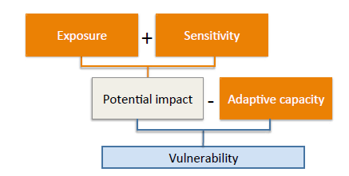
Figure 2: IPCC derived conceptual model of vulnerability.
Evaluation of adaptive capacity:
Adaptive capacity (AC) of a characteristic refers to its abilities and the resources available to cope with climate-related changes. In order to evaluate AC, three AC indicators are considered for each of the remaining characteristics in order to capture its abilities to adapt:
- Current state of the characteristic: What is the current situation of the characteristic? Is it in a fragile state or is it flourishing under the current conditions/environment?
- Level of human control over the characteristic: How much control do we actually have over the characteristic? Is it completely in the hands of stakeholders to control (e.g. fishing mortality) or is it completely out of their hands to control (e.g. growth rates)? Or is there some degree of control but not complete (e.g. employment)?
- Capacity to take adaptive action (financial resources, incentives and existing knowledge): What is the existing capacity of stakeholders to take action? This indicator involves three pillars: a) existing or pending financial resources to act, b) existing incentives among stakeholders (motivation, interest, importance) to act, and c) current (or pending) level of knowledge needed to take action (e.g. feedback loops of adaptive action and effects on wider production system).
Each of these three adaptive capacity indicators are scored from 1 (low AC) – 2 (medium AC) to 3 (high AC) as Table 1 below. Once all three adaptive capacity indicators have been given its score, the average AC score for the characteristic is calculated, giving it an overall AC score ranging from one (low adaptive capacity) to three (high adaptive capacity).
Table 1: Scoring adaptive capacity
AC indicators | Reference criteria |  | AC score
Current state of characteristic | - Bad current state of characteristic (e.g. impeded growth rates or low market prices)  - High frequency of occurrence of negative characteristic (e.g. algal blooms) – i.e. has been much less frequent in the past  - Low occurrence of positive characteristics (e.g. large cohorts) – has been much more frequent in the past |  | 1  (low AC)
Current state of characteristic | - Average current state of characteristic (e.g. acceptable growth rates and market prices)  - Average frequency of occurrence of negative characteristic (e.g. algal blooms) – i.e. has been less frequent in the past  - Average frequency of occurrence of positive characteristics (e.g. large cohorts) – i.e. has been more frequent in the past |  | 2  (medium AC)
Current state of characteristic | - Good current state of characteristic (e.g. high growth rates or good market prices)  - Infrequent occurrence of negative characteristic (e.g. algal blooms)  - Frequent occurrence of positive characteristics (e.g. large cohorts) |  | 3  (high AC)
Level of human control | - No or very limited ability of operators and/or authorities to control the state of the characteristic (e.g. floods and recruitment success) |  | 1  (low AC)
Level of human control | - Medium ability of operators and/or authorities to control the state of the characteristic (e.g. employment and disease outbreaks) |  | 2  (medium AC)
Level of human control | - Significant ability of operators and/or authorities to control the state of the characteristic (e.g. fishing mortality, infrastructure (cages/vessels) and licensing) |  | 3  (high AC)
Capacity to take action | Existing financial resources among stakeholders to act | 1 (no/limited) | Average score | 1 -1.5  (low AC)
Capacity to take action | Existing financial resources among stakeholders to act | 2 (some but more needed) | Average score | 1 -1.5  (low AC)
Capacity to take action | Existing financial resources among stakeholders to act | 3 (sufficient) | Average score | 1 -1.5  (low AC)
Capacity to take action | Existing incentives among stakeholders (motivation, interest, importance) to act | 1 (no/limited) | Average score | 1.6-2.5  (med. AC)
Capacity to take action |  | 2 (some but more needed) | Average score | 1.6-2.5  (med. AC)
Capacity to take action |  | 3 (sufficient) | Average score | 1.6-2.5  (med. AC)
Capacity to take action | Current (or pending) level of knowledge needed to act | 1 (no/limited) | Average score | 2.6-3  (high AC)
Capacity to take action | Current (or pending) level of knowledge needed to act | 2 (some but more needed) | Average score | 2.6-3  (high AC)
Capacity to take action | Current (or pending) level of knowledge needed to act | 3 (sufficient) | Average score | 2.6-3  (high AC)
(1-1,5: low AC; 1,6-2,5: medium AC; 2,6-3: high AC)
Assessment of vulnerability:
Once the AC score for each characteristic has been evaluated, the next step is to estimate the vulnerability of the characteristics. Vulnerability is a function of (exposure + sensitivity) – adaptive capacity. The CAP vulnerability assessment is conducted using a qualitative approach, as such an approach better accommodates data limited cases and the available data to conduct a fully quantitative assessment will seldom be sufficient. The CAP vulnerability assessment therefore uses a matrix to estimate the vulnerability, using the AC score (high-medium-low AC) and the (exposure + sensitivity) estimation from the risk assessment.
Given that the risk assessment method selected for each case will differ, the values used in the matrix will depend on the risk assessment method used. Below is an example of how such a vulnerability assessment matrix was used in the ClimeFish project to assess the vulnerability within seven European case studies. Here, the AC scores for each characteristic were set up against the consequence level for each impact, which was assessed in the ClimeFish risk assessment. This matrix approach (demonstrated below) can, however, be used irrelevant of the risk assessment method used in each case, by simply replacing the “consequence” level used below with the (exposure + sensitivity) estimation used for each case.
Table 2: The CAP vulnerability assessment matrix
AC score 🡪 | High AC  (2.5 - 3) | Medium AC  (1.6 -2.5) | Low AC  (1.5 - 1)
Consequence level ↓ | High AC  (2.5 - 3) | Medium AC  (1.6 -2.5) | Low AC  (1.5 - 1)
Extreme (4)
Major (3)
Moderate (2)

 | Low vulnerability |  |  | Medium vulnerability |  |  | High vulnerability

All remaining characteristics after the prioritisation process (Steps 1 and 2 in Task Two) are the characteristics that are most at risk and most vulnerable to climate change. Other characteristics will not be considered for any further action. The remaining characteristics will now be carried throughout the CAP development process, resulting in identification of adaptation measure(s) to address the adaptation need for each remaining characteristic.
Main contributor to Step 2: active participants with a good knowledge on daily operations within the production system, in order to be able to provide a relevant and realistic first estimation of the AC scores for each characteristic. Once the main contributors have provided the first assessment of the AC scores, it should be verified by a larger group of active participants with a wide background (administrative, legislative, operational), and ideally, stakeholders as well.
Additional input/verification to Step 2: The first draft of the AC score estimations must be open for verification by a larger group of active participants, and ideally, stakeholders.

Task Two: Step 3 - Identification of adaptation needs
Description: All remaining characteristics after the prioritisation process will enter Step 3. The number of characteristics will vary greatly between cases, usually ranging somewhere between ten and 30. Step 3 identifies the adaptation need for each characteristic. As defined by IPCC (2014), adaptation needs are the gap between what might happen as the climate changes and what we would desire to happen. The goal in Step 3 is therefore to define a broad future objective for each characteristic. Input from stakeholders is important in this step, as they are likely to have a clear vision regarding the desired future state of the characteristics, especially the production and socio-economic related ones. Setting a broad objective for each characteristic serves two purposes: a) It gives a clear picture of the adaptation needs for each characteristic, and b) it offers a direction of the adaptive action needed for each characteristic, i.e. what the adaptation measure must deliver for it to be effective.
The identification of a broad future objective should be done through the simple exercise of asking stakeholders: “What would the perfect future scenario for this characteristic be?”. The answer (and thus, the broad future objective) doesn’t need to be a single one-directional objective. Stakeholders with various backgrounds (e.g. scientist, fisherman, policy maker, NGO representative) might view the desirable state of each characteristic differently, and therefore the broad objective can include more than one goal. However, if the stakeholders come up with contradicting objectives that cannot go together, a common solution that all parties can agree on must be reached.
It is important to keep in mind that the broad future objective for a specific characteristic might be different when considered in the perspective of one impact vs. another. As an example of this (for a marine aquaculture case): the broad future objective of the characteristic growth rate, when considered as being affected by seasonal changes in growth and stocking timing will be different from when it is considered under the risk Suitability of farm sites. In the former, the broad future objective is likely to be along the lines of “Maintenance of high and stable growth rates”. For the latter (suitability of farm sites) the broad future objective could be “Access to and use of farming locations that sustain high and stable growth rates”. Due to these differences in the adaptation needs based on the risk involved, it is important to identify the broad future objective of each characteristic under each risk. The final conclusion on the broad objective of each characteristic is written in the column next to the characteristics in the CAP development template (see Annex 3), which is specifically set up in a way so that the user of the guidelines has an overview of all information available when determining the adaptive need (the broad future objective) for a characteristic, such as the risk involved, other characteristics, etc. This refers to all remaining steps in Task Two.
Main contributor to Step 3: As step 3 is highly connected to stakeholders’ input rather than being based on specific expertise, such as scientific or policy, any active participant in the CAP consortium can lead step 3.
Additional input/verification to Step 3: As all members of the CAP consortium can be considered stakeholders in the process (all having some vested interest in the production system), any additional verification/input from the group will benefit the results. It is therefore recommended to have a wider group from the CAP consortium to review and give input into step 3, with no specification of how that process should be performed (i.e. optional).

Task Two: Step 4 - Setting indicators and outcome targets
PLEASE NOTE
Task Two: Step 4 only needs to be performed for adaptation measures that fall under the category “industry level adaptation measures” (see Section 4.5: The setup of Climate Adaptation Plans). Thus, if the adaptation measure resulting from Step 4 and Step 5 is likely to be in the form of “knowledge building” or “policy recommendation”, this step does not need to be conducted.

Description: Now that the broad future objective has been set in Step 3, the adaptation needs has been realised and the adaptive action needed for each characteristic now has a direction, that is, what results it should achieve. While now having a sense of direction, the adaptive action (which will be in the form of adaptation measure) still needs more refining and clarification. Step 4 is performed to sharpen the focus of each adaptive action by giving it a specific outcome target (OT) and setting relevant performance indicators in order to be able to estimate the performance of the adaptation measures once it has been implemented. Again, it’s important to use the CAP development template and set OTs and indicators for each characteristic in the perspective of the different risks involved. Although the process requires the user to perform this exercise repetitively for the same characteristic under different risk-scenarios, it is still quite common that it results in the same outcome target and/or indicator for the same characteristic under different risk-scenarios. In other words, there is no requirement for the user to find different outcome targets/indicators for each characteristic under various risk-scenarios.
Step 4 can be split into two parts: 1) setting the indicators and 2) setting the OTs. Ideally, stakeholder’s feedback should be gained in these steps, to verify the appropriate outcome targets.
Setting indicators:
The CAP indicators are set for each remaining characteristic. A good indicator is measurable, and its measurements will give good indication of how well the adaptation measure is progressing in reaching the OT (i.e. the goal of the adaptation measure). The most effective way to set an indicator, is to start drafting it before setting the OT and the adaptation measure, that is, to only set it based on the broad future objective. By doing it this way, it should lead the user of the guidelines to the most appropriate OT and then consequently, the adaptation measure. It is however highly recommended to go back and revise the indicator and OT once the adaptation measures have been set in the end, as shown in Figure 3.
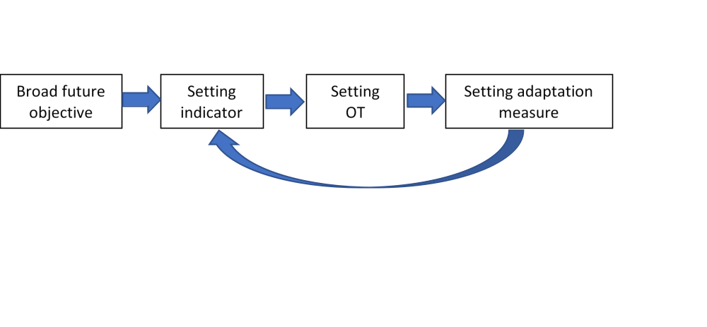
Figure 3: selection of indicators is an iterative process where the indicators must give relevant measurement on the success of the adaptation measure
When setting an indicator for a characteristic, the user must first consider the broad future objective set in Step 3. The broad future objective answers the question “How would you like to see the state of this characteristics in the future?” – and the indicator therefore needs to answer the question: “What can be measured to monitor how we are progressing in reaching this broad future objective?”.
Setting outcome targets (OTs):
Like the indicators, the OTs must be measurable and realistic for the production system in question. The OTs are expressed as threshold values of the respective indicators set previously, in other words, it is what we’d like to see the indicator measurements be (i.e. the goal of the adaptation measure). Below are a few examples of possible OTs for set indicators within an aquaculture production system.
Indicator | Outcome target
Growth rate (SGR) and ongrowing period at farm (time to market size) | Time to market size ≤ X days
Annual income (€ / year) | Increased profits (≥ X € / year)
Employment (as # of employees/farm) | Increased employment within industry (≥ X% of workforce)
Number of days (annual) where husbandry operation procedures are inhibited due to limited infrastructure durability to extreme weather | Number of non-operational days ≤ X days
Feeding costs (€ / ton of fish produced) | Feeding costs ≤ X% of production costs
Main contributor to Step 4: Active participants with a good knowledge on daily operations within the production system, to be able to provide relevant and realistic outcome targets and indicators.
Additional input/verification to Step 4: Indicators, and especially the OTs, should be verified by a larger group of active participants with the widest background possible (administrative, legislative, operational, etc.). Feedback from an extended group of stakeholders is also highly desirable and could be gained via stakeholder meetings, ideally along with giving their feedback on the identified adaptation measures (Step 5 – see below).

Task Two: Step 5 - Setting adaptation measures- the second stakeholder meeting
Description: When setting the adaptation measures, the user must incorporate the results from previous steps taken in Task Two, as the adaptation measures must:
- Help fulfil the adaptation need identified in Step 3;
- Contribute to reaching the OT set in Step 4 (only for industry-related AMs);
- Be possible to implement (be realistic).
Three levels of adaptation measures will be developed for three time-frames: short-term, middle-term, and long term.
- Industry level adaptation measures: Industry level adaptation measures refers to those measures that will be the responsibility of the operators, i.e. fishing fleets, fishers or fish farmers, and will not require changes in legislation. This category is the only one out of the three where outcome targets and indicators are required, as these are all measures that will be applied directly on the production processes, meaning that (in most cases) the changes in inputs or outputs can be measured. This will also enable the operators to estimate the success of the adaptation measures, by setting a relevant indicator and a desirable outcome target.
- Policy recommendations: This category includes all adaptation measures that were identified in the CAP process that either a) are industry level adaptation measures that require prior legislative change or b) are entirely in the hands of authorities (regional, national or European). As these adaptation measures cannot be implemented directly by the industry, they will be set forward in the form of policy recommendations, giving the relevant authorities guidance on desirable actions to increase the resilience of the sector towards climate change. These adaptation measures can range from being a simple, straight forward change in legislation, to a development of financial instrument(s) to facilitate other adaptation measures, such as funding schemes of technological development or research, establishment of subsidies, or an insurance framework to offer improved operational security. As these adaptation measures will be set out in the form of policy recommendations, outcome targets and indicators don’t need to be developed.
- Research and knowledge gaps: The third category includes research needs and knowledge gaps that need to be filled in order to a) implement an adaptation measure that is already identified or b) identify a suitable adaptation measure to fill an identified adaptive need. OTs and indicators do not need to be developed for this category. In many cases, it is clear what sort of adaptation measure is needed, but the best way to design or implement it remains unclear. An example of this is the need to develop and design breeding programs to breed more robust strains of farmed fish, i.e. fish that thrive under new and more challenging conditions. In these cases, identification of genes related to thermal adaptation is needed, as traits, such as environmental sensitivity and disease resistance might become new breeding goals. In this case, the adaptation measure is realised, but research is needed to clear the path of implementation.
The adaptation measures identified can be of various nature but should roughly be categorised into three categories based on the level of action needed and who will be responsible for implementing it (Table 3).

Table 3: The three adaptation measure categories with examples.
AM category | Type of action | Presented in CAP as | Responsible entity | Examples
Industry level | Actions within the production system’s processes that can be implemented by the industry itself without legislative changes | Suggested adaptation measures, including OTs and indicators to monitor progress. | Operators | - Improved monitoring activities (e.g. of water quality, mortalities, growth rates, etc.)  - Improved reporting of at-sea incidents  - Operation of breeding programmes
Policy recommen-dations | Legislative change to allow for implementation of an identified industry level adaptation measure | Suggestions and guidance for relevant authorities for desirable actions to increase the resilience of the production system towards climate change | Authorities | - Improved management of re-stocking activities  - Improved marine spatial planning (revised selection criteria for aquaculture site selection)
Policy recommen-dations | Actions entirely in the hands of authorities (regional, national or European) |  | Authorities | - Revision and settlement of allocation criteria for quota sharing agreements
Research and knowledge gaps | Research and knowledge building | Suggested research or identified key knowledge gaps | Scientists / academics | - Effects of copepods (Calanus finmarchicus) fishery on marine ecosystems  - Monitoring & mapping of parasitic infections  - Development of new technology
The identified adaptation measures in Step 4 must be verified and validated by the stakeholder group involved in the CAP development process. This should ideally be done in the second stakeholder meeting by setting up a group work activity or simply by giving the stakeholders scorecards. In the meeting, the identified adaptation measures, outcome targets and indicators are presented to the non-active participants. Here the non-active participants are asked about the applicability of the proposed adaptation measures and asked for information and suggestions regarding implementation, in order to be able to prepare the procedure plans (the final step of the CAP development process). This meeting could also be used to simultaneously validate the OTs that developed in Step 3. Stakeholders should be given an opportunity to give their feedback on several factors relating to the identified adaptation measures, most importantly the following:
- Will the adaptation measure increase the characteristics´ resilience towards climate change (i.e. does it address the identified adaptation need?)
  - Is the outcome target feasible?
  - If not – what sort of adaptation measure(s) could work?
- Can this adaptation measure be implemented within the production system?
  - If not, why?
  - If yes, what resources are required for its implementation? (financial, workforce, time, etc.)
Stakeholders´ overall feedback from this session should be taken into account when making the CAP’s final list of adaptation measures. Feedback and information received from stakeholders from question two above will become useful in Task Three: Implementation (Task Three).
Main contributor to Step 5: both active and non-active participants with a good knowledge on daily operations within the production system, in order to be able to provide a relevant and realistic first suggestions of adaptation measures.
Additional input/verification to Step 5: All identified adaptation measures must be verified by remaining active participants and the extended group of stakeholders. This should ideally happen in the CAP’s final stakeholder meeting, where all meeting participants should be given an opportunity to provide their feedback/scoring, through a dedicated group work/scoring session.

Task Three: Procedure Plans
After Task Two has been completed, the user of the guidelines will have a tailor-made set of relevant adaptation measures that together address the main vulnerabilities and risks of the production system towards climate change. While the CAP development process does not include the implementation of these adaptation measures, it does require the user to prepare for their implementation by creating procedure plans for each adaptation measure. This includes details on all main requirements behind their implementation, i.e. the task description (work effort), the responsible person or entity, the time frame and the cost estimation for the implementation. With this being the final task of the CAP development process, this task will leave the user(s) with a finalised Climate Adaptation Plan: A list of detailed adaptation measures and all relevant information needed to pave the way for their implementation.
As Task Three requires less work effort compared to Task One and Two and the task is of such nature that it could be conducted by one and the same active participants, the guidelines do not include details on main contributors for each step.
Leaders and participants of Task Three: Procedure Plans

Leader of Task Three
Knowledge required from leader: Good knowledge of the day-to-day operation of the production system, its management and administration, and its regulatory environment.

Task Three should be led by an active participant with good knowledge of the day-to-day operation of the production system and with good connections to both the operators within the industry, as well as all key parties relevant to the regulatory framework. The task requires a good overview of tasks and responsibilities of all parties related to the production system (e.g. operators, business owners, local, regional and national governance and administration), including their mandate and incentives to make regulatory/legislative amendments and their financial and workforce capacities. Compared to the task leaders in Task One and Task Two, the task leaders of Task Three should have good knowledge of, and connection to, the production system’s network beyond the daily operation, in order to be able to clearly identify the responsible entities for implementing each adaptation measure and their legal, financial and human capacities to do so.

Required contribution from other active/non-active participants
Knowledge required from other participants: Similar as for the leader, or a diverse group of participants, which together cover all key aspects needed.

The procedure plans should be verified by an extended group of active participants and ideally, an extended group of stakeholders (operators, administrative and governmental representatives).

Figure 4: Adaptation measures, its processes and tasks.

Adaptive
measures

Process 1

Task 1

Task2

Process 2

Task 1

Task2

Task Three: Step 1 – AM task description
Description
A finalised CAP must include details on all identified adaptation measures, including strategies defined precisely down to processes and further down to tasks (Figure 4). This step is important to better assess the work effort involved in the implementation process and gain understanding of the tasks ahead. This step describes in further detail how each adaptation measure can be implemented in order to meet the identified OTs (if an OT has been identified), thus taking the CAP one step closer to implementation.

Task Three: Step 2 – Procedure allocations
When implementing adaptation measures, it is important that all responsible persons/agencies/bodies are aware of and understand who will carry out or perform which procedure. To implement adaptation measures productively and increase the likelihood of reaching identified OTs, efficient management and allocation of procedures is essential. The allocation will vary between adaptation measures and can fall to one or various involved parties. The adaptation measures are divided into three categories based on the level of action needed (industry level, policy level or research level), to allow each adaptation measure to be set up in the desired format and prepare implementation. In the case of each category, there is always the one responsible party to which the category refers to, i.e. the industry in question for industry level, governmental agencies/policy makers for policy level and academic institutions/persons for research level. Furthermore, there can be more parties involved in the implementation and responsible for certain procedures for each category.
Example:
In a marine aquaculture production system, an adaptation measure for the industry level might be for a fish farmer to move the pens to a new location where circulation is better to clear out waste from the facility. The fish farmer would be responsible for the procedure of moving the pen. However, the farmer would need permits to move the pens to the new location. A governmental agency would then become the responsible party to provide the permit. Furthermore, there might be some uncertainty regarding whether the new location is a viable choice for fish farming pens due to lack of knowledge of the ecosystem in place. The government might allocate the procedure of researching the current situation and evaluating if the location can sustain fish farming to an academic institution, or a consultant.

Task Three: Step 3 – Resources
Estimating the resources necessary for implementing adaptation measures is another essential step for optimizing the implementation. The resources can be numerous and vary between adaptation measures. Some important and common ones are labour, time spent on preparation and implementation by involved parties, infrastructure needed to carry out the adaptation measures, capital for implementation, technology, etc.
Example:
Using the same example as in step 2, various resources are needed to implement the adaptation measure of moving the pens. The time needed for this measure would be the time the fish farmer needs to apply for the permit and then move the pens, the time the governmental agency needs to provide the permit and the time the academic institution needs to research the new location and give their evaluation. Furthermore, the fish farmer would need labour, appropriate machinery and vessels to transport the pens. Finally, he might need to make some adjustments to his current pens or operations which would require capital and perhaps additional technology.

Task Three: Step 4 – Cost estimation
With each implemented procedure in a given adaptation measure, there is a certain cost involved. This can be either in the form of fixed cost for equipment/work or variable costs for the responsible parties. It is vital for each party involved in the procedures to know beforehand what the expected cost of the implementation is, as it can easily become a decisive factor between two viable options of how to implement an adaptation measure. This cost estimation should therefore include every aspect of the operation and be made in accordance with all parties involved in each procedure. Should this be carried out accordingly, the chances of unexpected expenses are minimized.
Example
Carrying on with the examples given in the previous sections, the cost estimation of moving the pens would be carried out. The time spent discussing and passing new legislations in the senate/government would be estimated financially along with how much equipment would be needed to move the pens. This could be done by hiring private contractors on special vessels. New locations for the pens and the surrounding research also needs an evaluation, including on-site investigations as well as time allocated by specialists to arrive at a decision.

Task Three: Step 5 – Time Frame
Task description
The time frame of the procedures needs to be closely worked out in accordance with budget as these two aspects go hand in hand. This is case-specific and should therefore be carried out by the responsible parties in each case. This includes a broad long-term planning of the project as well as the planning of individual events in the processes down to each procedure. Relative timings should be considered where applicable, as area/processing closures in some instances are not always possible due to manufacturing constraints. Some safety margin should also be considered to cover unexpected delays in the process while implementing the adaptation measures.
Example
In the previous example, the time needed for governance to go over the permits for moving pens might be 4 weeks. If the permit is necessary for further action, the next action cannot be started until the end of this four-week period. Should the permit be given, another two weeks might be needed for hiring and setup of equipment to move the pens. Weather conditions should be considered and might affect the timing of when the process can be started. Final installations and finishing of work might then take 1-2 weeks, depending on the extensiveness of the procedures. Therefore, the overall time needed for this adaptation measure would in this instance be 7-8 weeks in total.

Evaluation of CAPs
The expected impacts of CAPs can either be assessed ex ante or ex post. In the former case, the effects of the CAPs can be assessed using quantitative or qualitative methods, while in the latter case the measures are only assessed after they have been implemented and sufficient time has elapsed to allow for a comprehensive assessment. As CAPs are usually intended to deal with expected impacts, it generally makes more sense to employ ex ante assessment.
Well-conducted ex ante impact assessment can support evidence-based policy-making and facilitate stakeholder participation in the whole process. The procedures for ex ante impact assessment includes: (1) Characterise measures, (2) Identify scope, i.e. who will be impacted, (3) Identify the nature of the impact, i.e. positive or negative, (4) Predict how impacts will evolve over time.
If possible, the adaptation measure should be included in models developed to analyse climate change and their impacts simulated. While this is a preferred option, some of the measures suggested may be too general or incompletely defined to allow for simulations. The impact of measures that cannot be simulated can be studied using a more qualitative approach, where the impacts are evaluated using a simple scale and possible trade-offs and synergies of the impacts discussed taking into account a balance between environmental/ ecological, social, economic and governance dimensions.

References
Barange, M., Bahri, T., Beveridge, M.C.M., Cochrane, K.L., Funge-Smith, S. & Poulain, F. (Eds). (2018). Impacts of climate change on fisheries and aquaculture: synthesis of current knowledge, adaptation and mitigation options. FAO Fisheries and Aquaculture Technical Paper No. 627. Rome, FAO. 628 pp
Brugère, C., & De Young, C. (2015). Assessing climate change vulnerability in fisheries and aquaculture. Available methodologies and their relevance for the sector. FAO Fisheries and Aquaculture Technical Paper No. 597. Rome, Italy. Retrieved from http://www.fao.org/documents/card/en/c/3a200d99-b9f5-4df0-9396-9a7ce2f6cf99/
Crane, A., & Ruebottom, T. (2011). Stakeholder Theory and Social Identity: Rethinking Stakeholder Identification. Journal of Business Ethics, 102(S1), 77–87. https://doi.org/10.1007/s10551-011-1191-4
FAO. (2003). Garcia, S.M.; Zerbi, A.; Aliaume, C.; Do Chi, T.; Lasserre, G. The ecosystem approach to fisheries. Issues, terminology, principles, institutional foundations, implementation and outlook. FAO Fisheries Technical Paper. No. 443. Rome, FAO. 2003. 71 p. http://www.fao.org/3/a-y4773e.pdf
FAO. (2010). Aquaculture development. 4. Ecosystem approach to aquaculture. FAO Technical Guidelines for Responsible Fisheries. No. 5, Suppl. 4. Rome, FAO. 2010. 53p. http://www.fao.org/3/i1750e/i1750e00.htm
FAO. (2018). The State of World Fisheries and Aquaculture 2018 - Meeting the sustainable development goals. Rome. Licence: CC BY-NC-SA 3.0 IGO. http://www.fao.org/3/i9540en/i9540en.pdf
Glick, P., B.A, Stein, and N.A. Edelson, editors. (2011). Scanning the conservation horizon: a guide to climate change vulnerability assessment. National Wildlife Federation, Washington, D.C.
Grafton, Q.R. (2010). Adaptation to climate change in marine capture fisheries. Marine Policy, 34(3), 606-615.
IPCC. (2014). Climate Change 2014: Synthesis Report. Contribution of Working Groups I, II and III to the Fifth Assessment Report of the Intergovernmental Panel on Climate Change. http://doi.org/10.1017/CBO9781107415324
Newton, A., & Elliott, M. (2016). A Typology of Stakeholders and Guidelines for Engagement in Transdisciplinary, Participatory Processes. Frontiers in Marine Science, 3, 230. https://doi.org/10.3389/fmars.2016.00230
Shelton, C (2014) Climate change adaptation in fisheries and aquaculture – compilation of initial examples. FAO Fisheries and Aquaculture Circular No. 1088. Rome, FAO. 34 pp

Annexes
Annex 1: System characteristic breakdown template
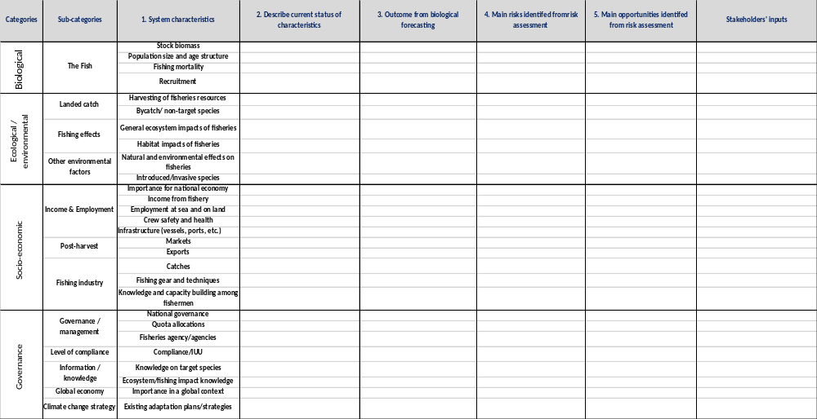
Figure 5: Suggested list of system characteristics for marine fisheries:

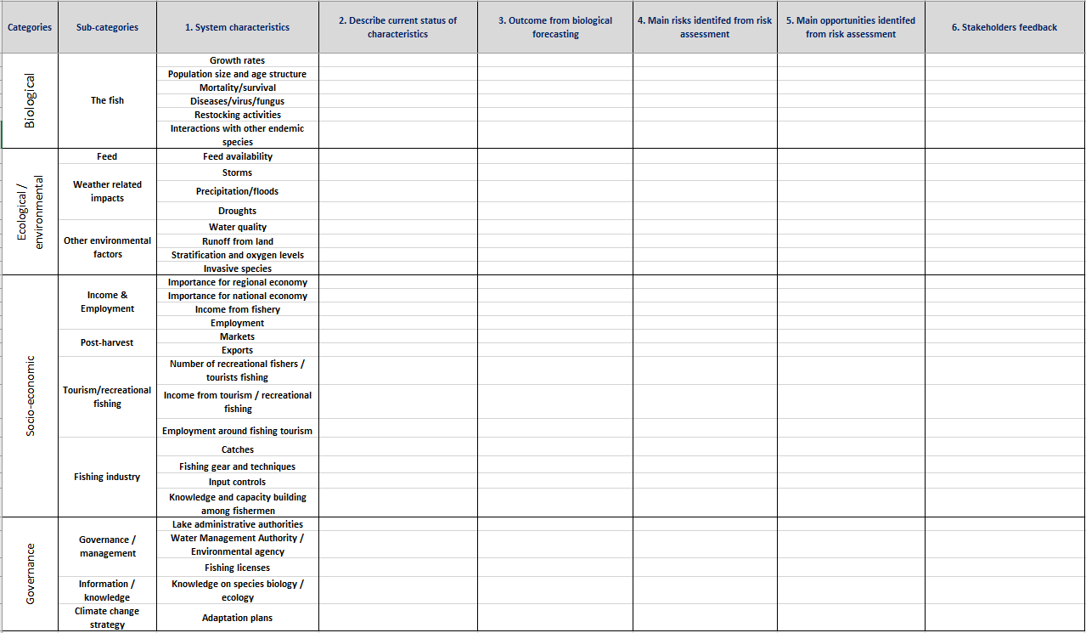
Figure 6: Suggested list of system characteristics for freshwater fisheries:

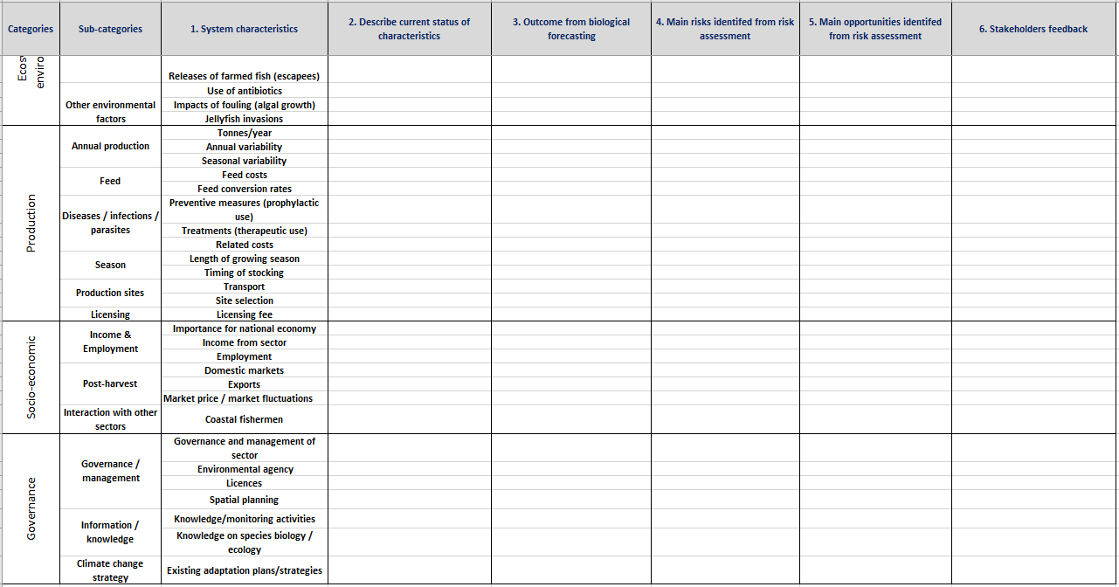
Figure 7: Suggested list of system characteristics for marine aquaculture:

Annex 2: IAM templates
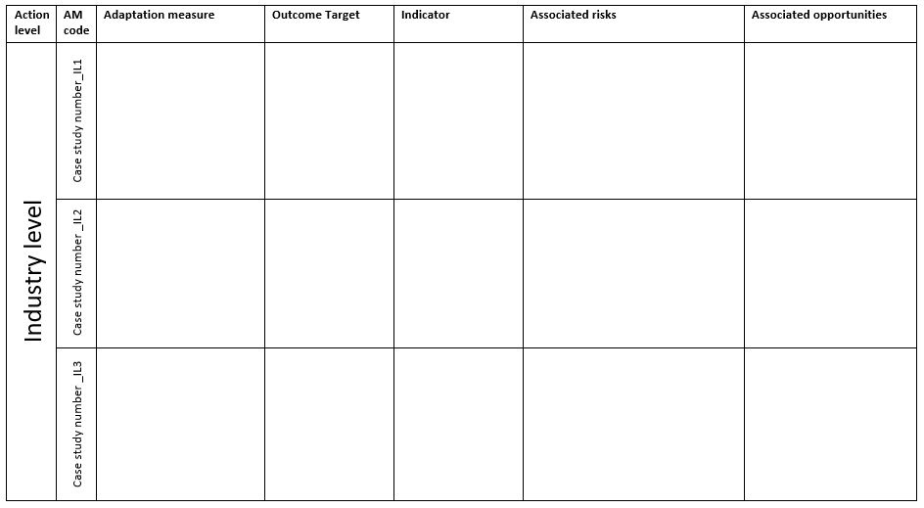
Figure 8: IAM template for industry level adaptation measures
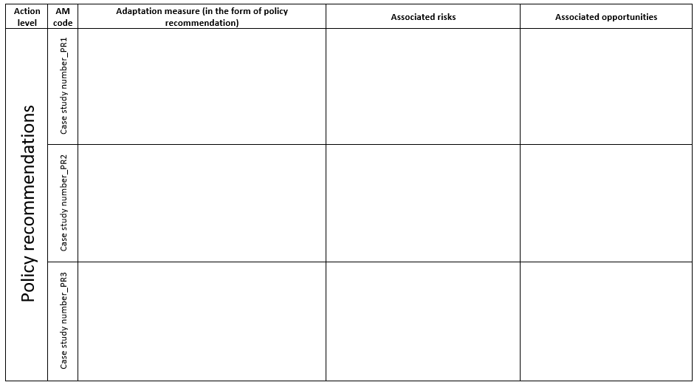
Figure 9: IAM template for industry level adaptation measures
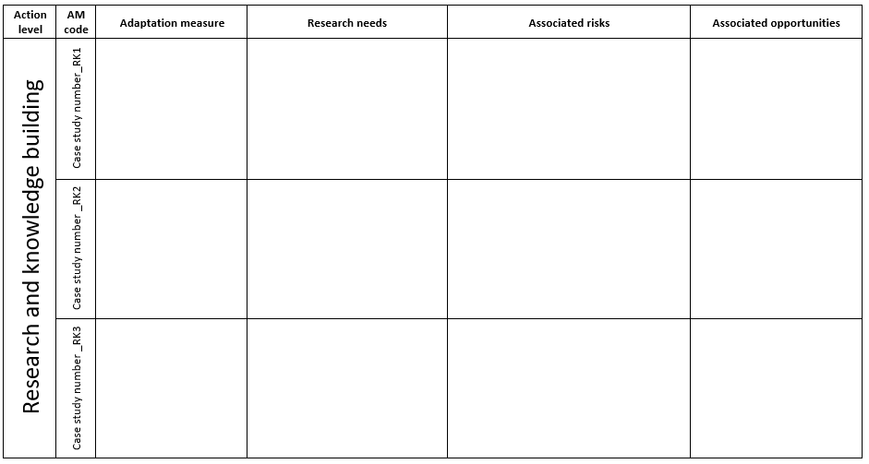
Figure 10: IAM template for industry level adaptation measures

As defined by FAO, fish is used as a collective term and includes mollusks, crustaceans and any aquatic animal which is harvested. FAO Fisheries and Aquaculture Department, FAO, 2018.
A seafood production system is referred to as the unit that is under the CAP assessment and can range from being a single seafood company to a national fishing/aquaculture industry. A seafood production system could therefore be e.g. a single fishery, a fishing industry (local or national), a single fish farm or an aquaculture industry (local or national).
The term stakeholder is used here to grasp the overall capacity of those who are related to the production system in one way or another, whether its the operators or the authorities. For the adaptive capacity indicators two and three, the control and capacity might be different between the operators and the authorities.

